**LIGHT WIRELESS FIDELITY V1.0**

*-ABHILASH S HEGDE & HIMANSHU SHARMA*

**Block Diagram:**

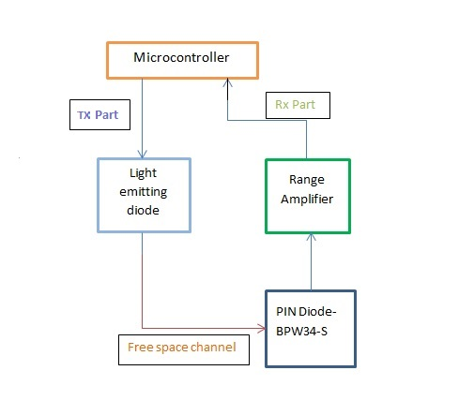

**Aim of Lifi v1.0**

* To transmit 8 bytes of data or more in approximately 1 minute 4 seconds time duration which gives the speed of 1bit/sec perfectly.
* Improvise the speed upto 64B/s.
* Making sure at least 80 bytes of text can be properly sent.
* Proof of concept and final TX and RX.
* Aim to finish working prototype of Lifi v1.0 within Aug’16.

**Observations during work:**

* Order of bits per alphabet/byte were appropriate after delay problem was fixed
* Used “Rx 0” & “ Rx 1” to show received bits/byte and then collected these bits in a user-defined variable which is then parsed after each byte reception and displayed for bit wise checking.
* After successful reception of each character, stored string sent onto a user-defined string which then displayed the character string sent from the Transmission End.
* Started at the speed of 1 bit/sec of character string reception then improved the speed to 12.5 bytes/second, upon successful reception we theorised for 12.5Kbytes/s and upon implementation got the achievable speed of 15Kbytes/s or 120Kb/s.

**Fixes and testing methodology:**

* Checked first for any hardware problem by debugging the circuit at all test points(Gnd,Supply,Diode etc),checked for connection lapses or loose contacts on breadboard & then finally operated the experiment to check the output voltages at OPAMP terminals when Light is incident upon the P-I-N photo-receiver diode.
* Next was a quick software check and fixing during multiple diagnosis of stages of project.
* Set 2 delays appropriately- one for LED output(Tx side) and other for P-I-N output(MC Side).
* Checked bit patterns for each character sent at 1bit/s, improvised to 12.5 B/s & then finally improvised to 12.5KB/s. All of these bit rates achieved the desired output practically a bit more faster(finally at 15KB/s approximated).
* Sent “JAI HIND JAI BHARATH” string at Tx Side and checked for the same reception at the max speed of around 15KB/s(120Kb/s).

**Result**: *Achieved the required aim for Lifi v1.0 and finished all these on 24.08.16.*